**AD110: USER INTERFACE DESIGN - Project 2**

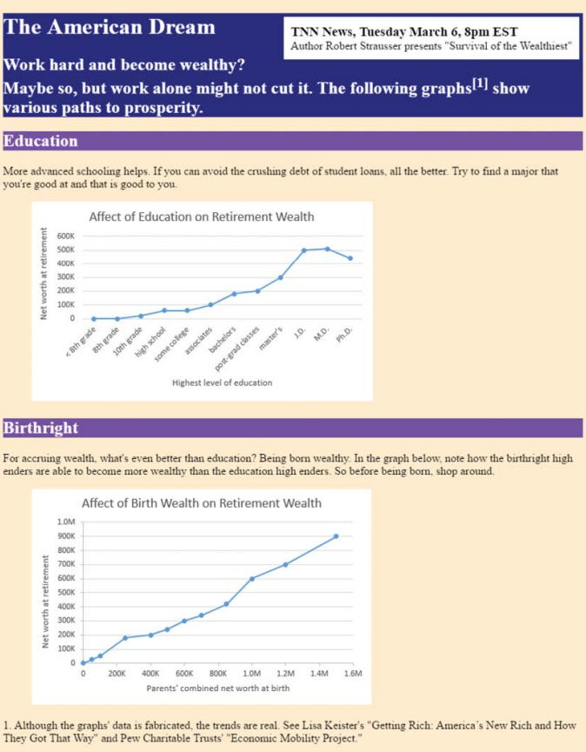

**The American Dream**

**Project Description:**

Provide complete code for an implementation of the following web page and name the file wealth.html. To make each of the two figures, you can generate a line graph with Microsoft Excel, copy the result to Microsoft Paint, and save the pasted image as a .png file. As an option, feel free to insert a third graph above the other two graphs that shows how the average number of hours worked per week affects retirement wealth.

In the web page, note the superscripted “[1]” in the third line. That is a link to the message at the bottom of the web page. The W3C recommends implementing a footnote by using a link. The link contents should be a square-bracketed number, and the link should be superscripted.

To make the link look good, the web page uses these CSS rules:

a {color: white; text-decoration: none;}

a:hover {text-decoration: underline;}

As always, make sure you use appropriate containers so that your web page’s content is properly defined. In particular, you should include aside, header, article, section, and figure elements.

Submit your complete summary to **Project 2 in Moodle**.

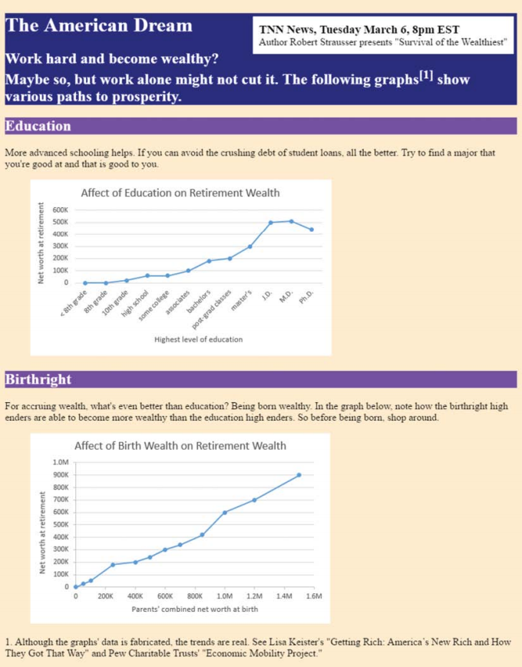**FOR INSTRUCTOR USE ONLY**

**Grading Rubric**

*Grading accepts a start value of 100. Points will be deducted for failure to fully complete or meet the stated requirements. Grading: 90-100 = Represents work of superior quality (A); 80-89 = Represents work of good to very good quality (B); 70-79 = Represents adequate command of class content (C); 69 and below = Represents work that shows a need for development or improvement (F); 0 = Represents plagiarized work (F).*

**AD110: USER INTERFACE DESIGN (NCP-WEB)**

**Student:**

**Instructor:**

**Date:**

**Project 2**

|  |  |  |
| --- | --- | --- |
| **Description of requirements** | **Possible Points** | **Your Points** |
| Provide complete code for an implementation of the following web page and name the file wealth.html | **25** |  |
| Generate a line graph with Microsoft Excel, copy the result to Microsoft Paint, and save the pasted image as a .png fil | **25** |  |
| Implement a footnote by using a link. The link contents should be a square-bracketed number, and the link should be superscripted. | **20** |  |
| Use appropriate containers so that your web page’s content is properly defined. In particular, you should include aside, header, article, section, and figure elements. | **30** |  |
| **TOTAL** | **100** |  |

**YOUR SCORE**: ________

**Instructor Comments:**